Datasets: Development of a real-time testbed for renewable energy integration studies
Figure one below illestrates the main testbed circuit housed in the SM target subsystem. Table I then proceedss to specify various parameters selected for components observed in Figure 1. These parameters represent those selected for the components at the time when case studies of the thesis were performed.
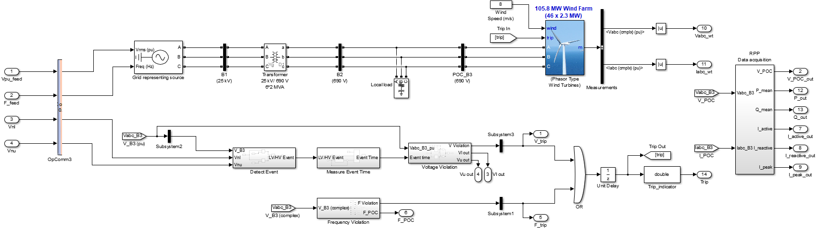
Main circuit section
Voltage validation
Frequency validation
Figure 1. Main testbed circuit (SM target subsystem).

Table I. Testbed component parameters selected in MATLAB for performing the research case studies.
Main circuit section parameters:
Grid representing source:
Generator type | Swing
Nominal voltage (phase-to-phase) | 25 kV
Nominal frequency | 50 Hz
Phase angle | 0 degrees
Inputs | Voltage (pu) and Frequency (Hz) from “V&F circuit inputs, case study 1-9 datasets”
Output | Three-phase grid representing voltage and frequency to the circuit/testbed
Bus 1:
Voltage | 25 kV
Measurements from this bus | None
Transformer:
Configuration | Yg-Delta
Nominal power | 2.6 MVA
Winding 1 Vph-ph | 25 kV
Winding 1 R (pu) | 0.025/30
Winding 1 L (pu) | 0.025
Winding 2 Vph-ph | 690 V
Winding 2 R (pu) | 0.025/30
Winding 2 L (pu) | 0.025
Magnetization resistance Rm (pu) | 500
Magnetization inductance Lm (pu) | inf
Bus 2:
Voltage | 690 V
Measurements from this bus | None
Local load
Type | Three-phase series RLC load
Configuration | Y (grounded)
Nominal Vph-ph | 690 V
Nominal frequency | 50 Hz
Load type | Constant current (I)
Active power (P) | 100 MW
Inductive reactive power (QL) | 0 kVAR
Capacitive reactive power (Qc) | 300 kVAR
Bus 3 (POC Bus):
Voltage | 690 V
Measurements from this bus | Complex pu POC voltage and current
Simulated renewable power plant [1,2]:
Type | Phasor type wind turbines
Size | 105.8 MW (46 x 2.3 MW)
Output voltage | 690 V
Mode | Voltage regulation
Nominal frequency | 50 Hz
Magnetizing inductance Lm (pu) | 2.9
Inertia constant | 5.04
Wind input speed | 8 m/s
Trip input | From voltage and frequency validation subsystems
Measurements | Complex three-phase voltage and current (pu)
Voltage validation subsection:
Grid code voltage parameters | Category C RPP’s, >20 MVA
Umin (Vnl) | 0.85 pu
Umax (Vnu) | 1.1 pu
Frequency validation subsection:
Grid code frequency parameters | Same for all renewable generation in South Africa
Fnl | 49 Hz
Fnu | 51 Hz

References:
[1] Eskom, “Fact Sheet – Sere wind farm”. Eskom Powering your world. https://www.eskom.co.za/wp-content/uploads/2021/08/RW-0000-Sere-Wind-Farm-Rev-3.pdf (accessed Feb 10, 2023).
[2] Siemens, “Siemens wind turbine SWT. The new productivity benchmark”. Siemens Wind Turbine SWT-2.3-108. https://docplayer.net/20757562-Siemens-wind-turbine-swt-2-3-108-the-new-productivity-benchmark-www-siemens-com-wind.html (accessed July 14, 2022).

