Green products, not too green to clean

My Dashboard

Survey Overview

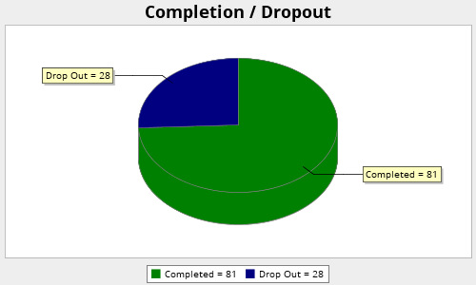

Viewed  309 | Started  109 | Completed  81 | Completion Rate  74.31% | Drop Outs (After Starting)  28 | Average Time to Complete Survey  5 minutes

Q1. Gender

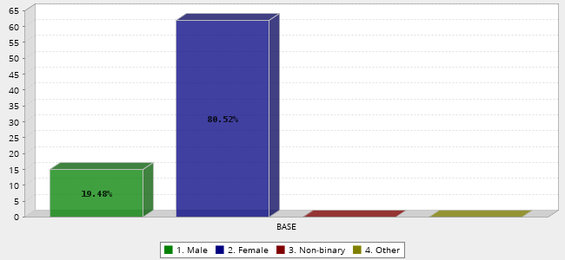
 |  | Answer |  |  |  | Count | Percent
1. |  | Male |  |  |  | 15 | 19.48%
2. |  | Female |  |  |  | 62 | 80.52%
3. |  | Non-binary |  |  |  | 0 | 0.00%
4. |  | Other |  |  |  | 0 | 0.00%
 |  | Total |  |  |  | 77 | 100%
 | Mean : 1.805 |  | Confidence Interval @ 95% : [1.716 - 1.894] | Standard Deviation : 0.399 | Standard Error : 0.045
Q2. Age

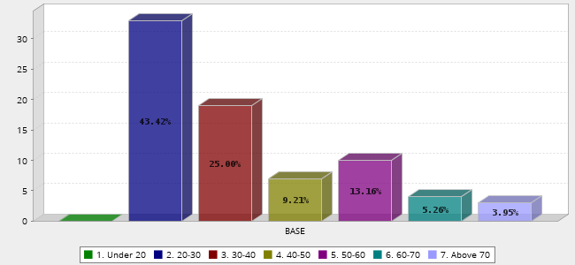
 |  | Answer |  |  |  | Count | Percent
1. |  | Under 20 |  |  |  | 0 | 0.00%
2. |  | 20-30 |  |  |  | 33 | 43.42%
3. |  | 30-40 |  |  |  | 19 | 25.00%
4. |  | 40-50 |  |  |  | 7 | 9.21%
5. |  | 50-60 |  |  |  | 10 | 13.16%
6. |  | 60-70 |  |  |  | 4 | 5.26%
7. |  | Above 70 |  |  |  | 3 | 3.95%
 |  | Total |  |  |  | 76 | 100%
 | Mean : 3.237 |  | Confidence Interval @ 95% : [2.909 - 3.565] | Standard Deviation : 1.459 | Standard Error : 0.167
Q3. Do you consider your effect on the environment as a consumer before purchasing general day to day products?

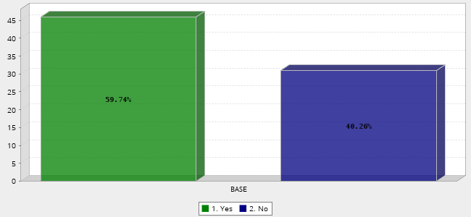
 |  | Answer |  |  |  | Count | Percent
1. |  | Yes |  |  |  | 46 | 59.74%
2. |  | No |  |  |  | 31 | 40.26%
 |  | Total |  |  |  | 77 | 100%
 | Mean : 1.403 |  | Confidence Interval @ 95% : [1.292 - 1.513] | Standard Deviation : 0.494 | Standard Error : 0.056
Q4. Do you regularly recycle product packaging?

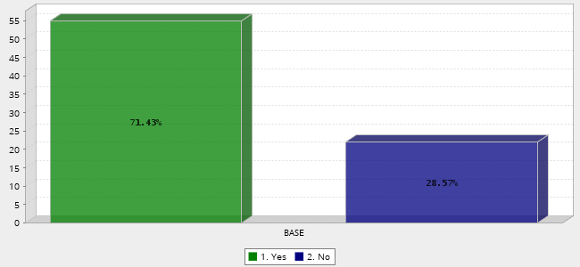
 |  | Answer |  |  |  | Count | Percent
1. |  | Yes |  |  |  | 55 | 71.43%
2. |  | No |  |  |  | 22 | 28.57%
 |  | Total |  |  |  | 77 | 100%
 | Mean : 1.286 |  | Confidence Interval @ 95% : [1.184 - 1.387] | Standard Deviation : 0.455 | Standard Error : 0.052
Q5. Are you aware of any products which are designed with environmental issues in mind?

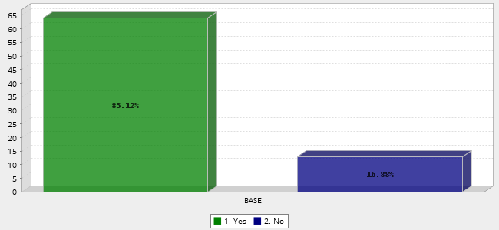
 |  | Answer |  |  |  | Count | Percent
1. |  | Yes |  |  |  | 64 | 83.12%
2. |  | No |  |  |  | 13 | 16.88%
 |  | Total |  |  |  | 77 | 100%
 | Mean : 1.169 |  | Confidence Interval @ 95% : [1.085 - 1.253] | Standard Deviation : 0.377 | Standard Error : 0.043
Q6. Have you ever bought or considered buying products which are designed with environmental issues in mind?

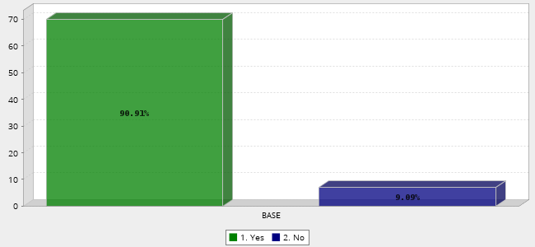
 |  | Answer |  |  |  | Count | Percent
1. |  | Yes |  |  |  | 70 | 90.91%
2. |  | No |  |  |  | 7 | 9.09%
 |  | Total |  |  |  | 77 | 100%
 | Mean : 1.091 |  | Confidence Interval @ 95% : [1.026 - 1.156] | Standard Deviation : 0.289 | Standard Error : 0.033
Q7. What has been your experience using green products? Select one or more from the list.

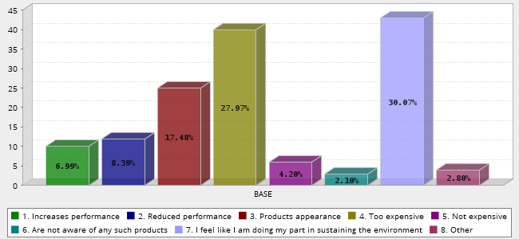
 |  | Answer |  |  |  | Count | Percent
1. |  | Increases performance |  |  |  | 10 | 6.99%
2. |  | Reduced performance |  |  |  | 12 | 8.39%
3. |  | Products appearance |  |  |  | 25 | 17.48%
4. |  | Too expensive |  |  |  | 40 | 27.97%
5. |  | Not expensive |  |  |  | 6 | 4.20%
6. |  | Are not aware of any such products |  |  |  | 3 | 2.10%
7. |  | I feel like I am doing my part in sustaining the environment |  |  |  | 43 | 30.07%
8. |  | Other |  |  |  | 4 | 2.80%
 |  | Total |  |  |  | 143 | 100%
 | Mean : 4.545 |  | Confidence Interval @ 95% : [4.212 - 4.879] | Standard Deviation : 2.037 | Standard Error : 0.170
Q17. If your answer above was other, please specify bellow

43860193 | .
43846497 | None
43844180 | None
43843909 | I cant elaborate on my experience because I've had little to no experience with any or many products
43843423 | Tends to be more time consuming
43279560 | N/A
43247327 | N/A
43247117 | Na
43164766 | Na
43161292 | Smells are generally less artificial. Also, products can generally be used for multiple purposes which is a plus.
43143760 | NA
43105416 | NA
43098802 | N/a
43088997 | Not always readily available, not even at bigger retailers
43049616 | -
43049380 | I found the green cleaning products I have purchased are generally quite expensive as a once off payment even though they stretch over a 2/3 month period. It's difficult to have the funds readily available when the products run out. Especially when having children and pets there are always unforseen expenses. Also I have found some products work well and others not do much. Bare in mind I generally buy my products from private suppliers and not grocery stores.
42986587 | none
42974436 | N/A
Q8. What makes you trust something?

43879070 | If I feel it works well
43878010 | If it works
43875376 | My knowledge of the material that it is made of.
43874635 | Performance, good prices, reputable company
43873977 | If it is scientifically tested
43860193 | If friends recommend it
43858592 | Nothing
43856011 | I think reviews on products usually assist consumers.
43849328 | Performance
43846522 | The brand.
43846497 | Goof performance and great reviews
43844565 | Good experiences
43844180 | Professional packaging. Track record
43843909 | The brand. Quality. Durability. Effectiveness.
43843423 | Transparency from the company, reading up on the company
43843089 | Look and effective
43842876 | Conformation from other sources that a particular product is as it claims to be
43279560 | Experience/ research
43250135 | Brand familiarity
43248227 | If I know that the brand, is known to be environment friendly and cares about its consumer's wellbeing and experience.
43247664 | Reliability
43247327 | Accurate and truthful information
43247237 | The package needs to look interesting and the price needs to be affordable.
43247117 | If it has a green eco logo on the packaging
43246796 | Clear and easy information. Transparency of product creation
43246714 | Quality over quantity
43164766 | Function
43161292 | Appearance of the product (if never used before) Labeling (aka, what it promotes) Past experience
43155785 | Usually a trustworthy website
43153848 | Packaging and the brand appearance on social media and media overall
43150832 | Brand Name
43150435 | i think mainly advertising/labelling e.g. not tested on animals
43145481 | Successful results
43143760 | If I know it works well or that there are reviews on it that are good.
43143738 | The functionality and the ethical background
43143714 | If the quality is good and trustworthy ill use it
43143541 | Where I buy a product (e.g Woolworths) otherwise, previous reviews when purchasing from anywhere else.
43112874 | If I have used it before and it actually works or if the brand is aware of their packaging and make their packaging recyclable
43108318 | Quality
43105786 | If it's well known or backed by people I trust.
43105416 | The wording on the product, the facts.
43101926 | When it does what it says it should
43098802 | The look and feel to it.
43095511 | a good packaging - although it might not be a representation of what is inside, i tend to pick those above the others. also for example woolies packaging, it's very plain, much less printing needed than elaborate packaging in other stores and woolies packaging looks better, i trust woolies more
43093470 | Consumer support and product reviews.
43088997 | Experience and recommendations
43078770 | Information about the product, how it is manufactured and from which recycled products, how does the local community benifit from this product
43076614 | Personal experience
43075789 | I trust a product that gives me what I paid for. If the product says it does xyz and gives me xyz I will trust it going forward.
43068846 | Recommendations, good reviews, locally made
43056913 | Reliability from previous usage
43051527 | If I read reviews and use it for the first time myself before giving my own opinion on it and if I trust it or not
43050719 | I look at what is in the product and if it is a non animal trial product
43050174 | Reputation of the brand
43050172 | Product ratings and reviews, attractive packaging, reasonable price point (not super cheap as it might indicate lower quality, but not overpriced either), ingredients/materials list, recommendations.
43050008 | Quality
43049795 | -Quality of product -Appearance
43049616 | Previous experience. Word of mouth.
43049407 | The businesses ethics
43049381 | Reputation of the company
43049380 | When I can see real proof of how something works.
43048541 | Being a Proudly South African Product
42986587 | Popularity of a brand or trial and error
42985985 | A well designed brand.
42974436 | Being able to clearly read each and every ingredient. Also if the packaging itself is very bad for the environment, then it makes me question the authenticity of the contents. Also if it has been approved by eco reputable groups.
Q9. What is the factor that makes you trust on the brand that you use?

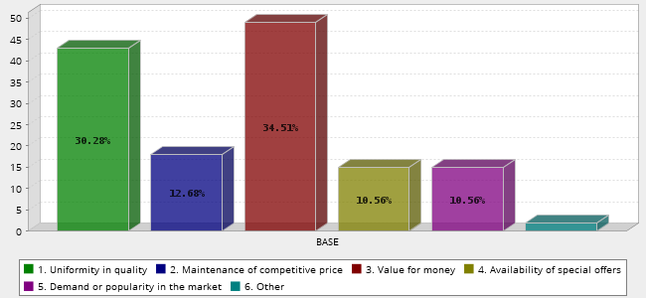
 |  | Answer |  |  |  | Count | Percent
1. |  | Uniformity in quality |  |  |  | 43 | 30.28%
2. |  | Maintenance of competitive price |  |  |  | 18 | 12.68%
3. |  | Value for money |  |  |  | 49 | 34.51%
4. |  | Availability of special offers |  |  |  | 15 | 10.56%
5. |  | Demand or popularity in the market |  |  |  | 15 | 10.56%
6. |  | Other |  |  |  | 2 | 1.41%
 |  | Total |  |  |  | 142 | 100%
 | Mean : 2.627 |  | Confidence Interval @ 95% : [2.402 - 2.851] | Standard Deviation : 1.366 | Standard Error : 0.115
Q18. If your answer above was other, please specify bellow

44015192 | Quality and value for.money
43860193 | .
43846497 | Not applicable
43844180 | None
43279560 | N/A
43247327 | N/A
43247117 | Na
43164766 | Na
43145481 | If the brand is actually making an impact with results and proof that it does help with the environment, sure. But take straws for instance, or woolies taking the initiative to change their bags. But they don’t change what they put in the stores that people buy? And that paper straw that you drink out of at steers is in a plastic cup? So what happens to that cup? All fairness, a product packaging can make a change but if you look at the bigger picture we shouldn’t even have packaging to begin with, only reusable containers that can be refilled.
43143760 | NA
43105416 | NA
43098802 | N/a
43049616 | -
42986587 | none
42974436 | N/A
Q10. What is the possible factor that can affect your trust in the brand?

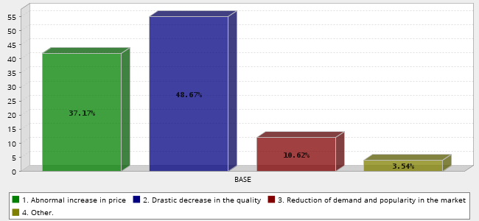
 |  | Answer |  |  |  | Count | Percent
1. |  | Abnormal increase in price |  |  |  | 42 | 37.17%
2. |  | Drastic decrease in the quality |  |  |  | 55 | 48.67%
3. |  | Reduction of demand and popularity in the market |  |  |  | 12 | 10.62%
4. |  | Other. |  |  |  | 4 | 3.54%
 |  | Total |  |  |  | 113 | 100%
 | Mean : 1.805 |  | Confidence Interval @ 95% : [1.664 - 1.947] | Standard Deviation : 0.766 | Standard Error : 0.072
Q19. If your answer above was other, please specify bellow

43860193 | .
43846497 | Not applicable
43844180 | None
43279560 | N/A
43247664 | Brands social presents.
43247327 | N/A
43247117 | Na
43173990 | Unnecessary changes in specification eg. New improved, change of smell etc.
43164766 | NA
43145481 | Again end results
43143760 | NA
43143738 | Change in attitude
43105416 | NA
43098802 | N/a
43049616 | -
42986587 | none
42974436 | N/A
Q11. How familiar are you with these brands in these eco-friendly cleaning ranges? Click on the brands you are familiar with.

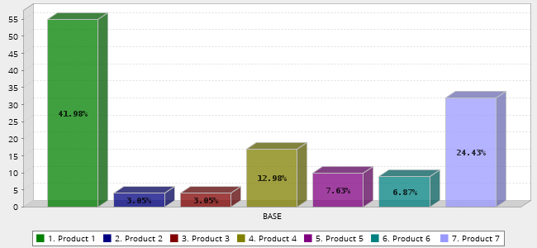
 |  | Answer |  |  |  | Count | Percent
1. |  | Product 1 |  |  |  | 55 | 41.98%
2. |  | Product 2 |  |  |  | 4 | 3.05%
3. |  | Product 3 |  |  |  | 4 | 3.05%
4. |  | Product 4 |  |  |  | 17 | 12.98%
5. |  | Product 5 |  |  |  | 10 | 7.63%
6. |  | Product 6 |  |  |  | 9 | 6.87%
7. |  | Product 7 |  |  |  | 32 | 24.43%
 |  | Total |  |  |  | 131 | 100%
 | Mean : 3.595 |  | Confidence Interval @ 95% : [3.163 - 4.027] | Standard Deviation : 2.523 | Standard Error : 0.220
Q12. Click on the adverts that you feel provides you with trust that the product/s been advertised are green, sustainable, or eco-friendly

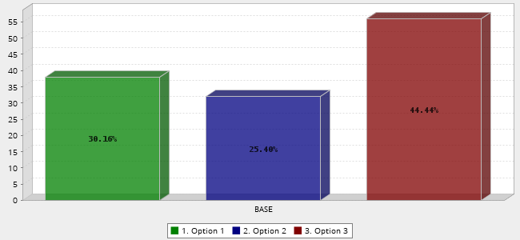
 |  | Answer |  |  |  | Count | Percent
1. |  | Option 1 |  |  |  | 38 | 30.16%
2. |  | Option 2 |  |  |  | 32 | 25.40%
3. |  | Option 3 |  |  |  | 56 | 44.44%
 |  | Total |  |  |  | 126 | 100%
 | Mean : 2.143 |  | Confidence Interval @ 95% : [1.994 - 2.292] | Standard Deviation : 0.855 | Standard Error : 0.076
Q13. From the above adverts, is it the wording, logos or colour that gives you the understanding that these products are eco-friendly

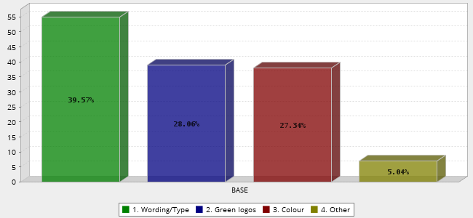
 |  | Answer |  |  |  | Count | Percent
1. |  | Wording/Type |  |  |  | 55 | 39.57%
2. |  | Green logos |  |  |  | 39 | 28.06%
3. |  | Colour |  |  |  | 38 | 27.34%
4. |  | Other |  |  |  | 7 | 5.04%
 |  | Total |  |  |  | 139 | 100%
 | Mean : 1.978 |  | Confidence Interval @ 95% : [1.823 - 2.134] | Standard Deviation : 0.936 | Standard Error : 0.079
Q20. If your answer above was other, please specify bellow

43860193 | .
43846497 | Not applicable
43844180 | None
43843909 | Woolworths is a brand that i associate with quality and sustainability
43279560 | N/A
43247664 | Checked boxes - First thing I look for.
43247327 | N/A
43247117 | Na
43173990 | Dont know any of the above products.
43164766 | Na
43161292 | Introduction of natural elements (e.g. fruit/herb imagery within the simple truth as)
43145481 | To be honest, none of these look eco friendly because of the packaging associated with plastic. I just like the style and vibrancy of the overall advert but none of them show eco friendly to me.
43143760 | NA
43105416 | NA
43098802 | N/a
43078770 | The track record of the supplier for example woolworths.
43051527 | You see current words. Or images that shows you the eco-friendly of the product
43049616 | -
42986587 | none
42974436 | N/A
Q14. Read the following headings of green brands: A. New eco-conscious Live Green cleaning range is made from biodegradable plant-based materials that are cruelty – and guilty-free. B. Living healthy, eco-friendly cleaning products. C. Eco Range. D. Eco-conscious cleaning range. E. Range of affordable cleaning products which are eco-friendly, cruelty free and made with biodegradable materials. F. Biodegradable and non-toxic G. Earth friendly – made with biodegradable cleaning ingredients. Would this information change your choice to purchase a green product verse a non-green product?

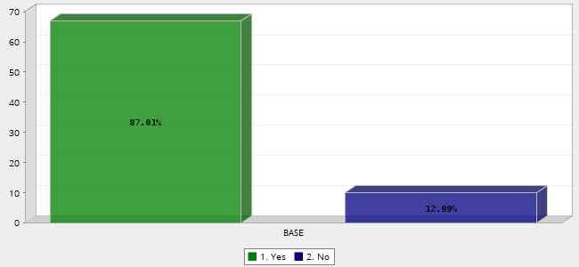
 |  | Answer |  |  |  | Count | Percent
1. |  | Yes |  |  |  | 67 | 87.01%
2. |  | No |  |  |  | 10 | 12.99%
 |  | Total |  |  |  | 77 | 100%
 | Mean : 1.130 |  | Confidence Interval @ 95% : [1.054 - 1.205] | Standard Deviation : 0.338 | Standard Error : 0.039
Q15. Assess the following logos of green cleaning brands: Click on the logos that you fell add trustworthiness to your discission making of these brands?

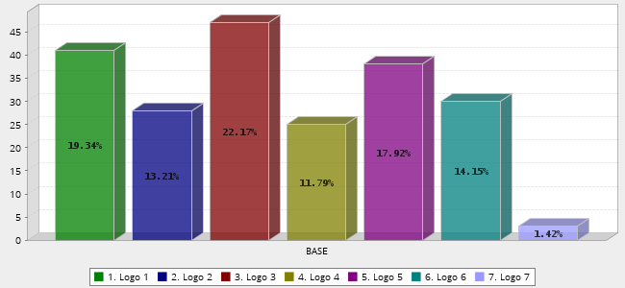
 |  | Answer |  |  |  | Count | Percent
1. |  | Logo 1 |  |  |  | 41 | 19.34%
2. |  | Logo 2 |  |  |  | 28 | 13.21%
3. |  | Logo 3 |  |  |  | 47 | 22.17%
4. |  | Logo 4 |  |  |  | 25 | 11.79%
5. |  | Logo 5 |  |  |  | 38 | 17.92%
6. |  | Logo 6 |  |  |  | 30 | 14.15%
7. |  | Logo 7 |  |  |  | 3 | 1.42%
 |  | Total |  |  |  | 212 | 100%
 | Mean : 3.439 |  | Confidence Interval @ 95% : [3.203 - 3.674] | Standard Deviation : 1.750 | Standard Error : 0.120

