Sureshinee Govender
Master of Technology: Public Relations Management

Dissertation: An evaluation of the use of social media in the enhancement of stakeholder engagement in a public institution.

- Summary
This study investigates the use of social media for public engagement purposes by South Africa’s parliament. While the use of social media by corporations and individuals for business and activism purposes has received an extensive scholarship, there remains a gap when it comes to an understanding of its uses by arms of the state in promoting public engagement. Therefore, this study becomes one of the seminal works on how South Africa’s state components are appropriating social media for public engagement purposes. This qualitative study used a Twitter sample of six months between November 2018 and April 2019 to understand this developing trend. Critically, this qualitative study sought to understand three things: the uses, effect, and nature of public engagement mediated via South Africa’s parliament Twitter handle. The researcher sought to test the effect, if at all, of integrating social media by the parliament in its public engagement exercise. The preferred design for this study was netnography as it allowed the researcher to harvest social media data with no ethical dilemmas. Social media handles of public officials and governments are considered public property; hence the researcher was within the acceptable norms by harvesting data for this study. Public relations’ stakeholder models were employed as preferred theoretical lenses. The study found that there existed some inconsistency with regards to messaging when it comes to the use of social media. This inconsistency was further bolstered by the fact that the parliament, though using interactive technology, still operated in a top-down monologue approach as there was no engagement in the real sense. The parliament Twitter handle acts in the same way traditional television or newspaper operated by passing information without necessarily engaging with the audience.

STEP BY STEP GUIDE TO READ ANALYTICS

- Go to excel spreadsheet, click on column A, it will open on top box, click from http to the end of the figures, as below:
https://twitter.com/ParliamentofRSA/status/1113813919016079361
Thereafter copy and paste into Google. 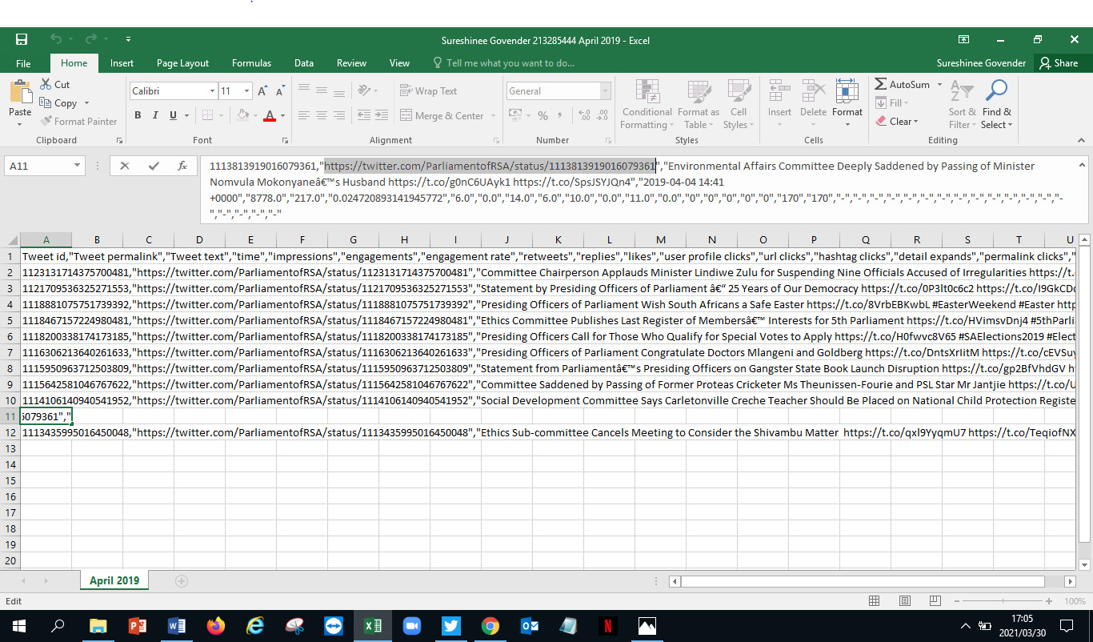

- Once copied, then paste in Google, the link will open up the Tweet on Twitter as below.

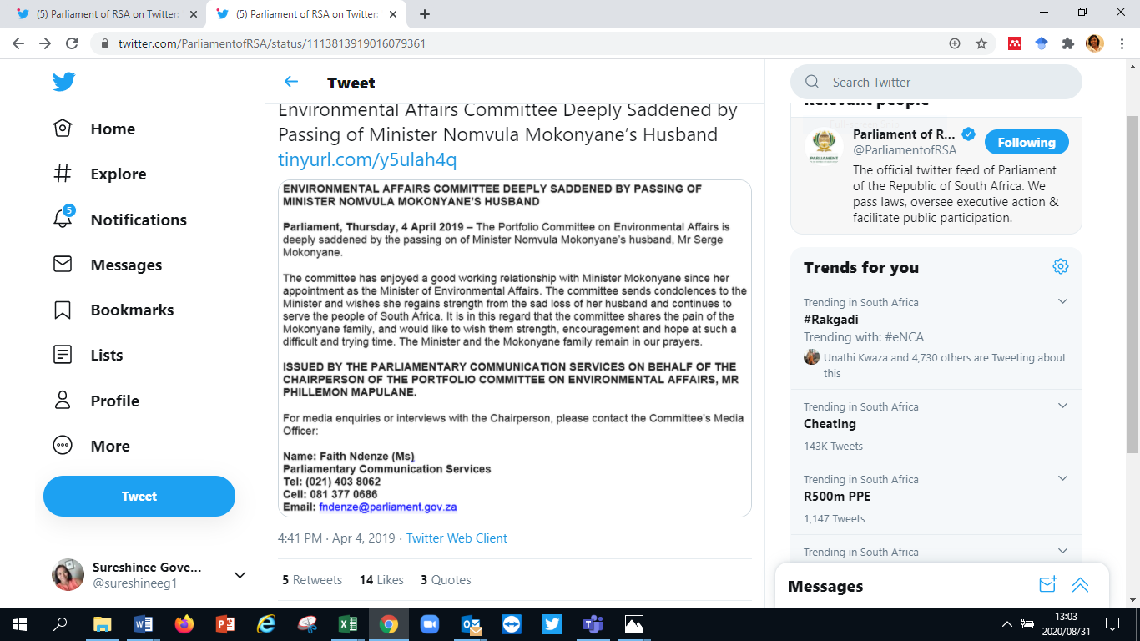

- Analysis
The Tweets were dissected and categorised according to whether the Tweet was Informational, Promotional, Participatory/Interactive or Collaborative. The level of public engagement was determined by looking at the comments which were scrutinised to determine if they had a positive or negative impact. The researcher also looked at Retweets and what interested the public to warrant a Retweet, whether a URL was provided, the use of Hashtags, Pictures and Videos to enhance the content of the messaging and whether there were responses to questions posed by the public. Likes were also observed to determine what was important or of interest to the public.
Table 3 on page 43 in the dissertation provides a snapshot of the analysis. The researcher looked for trends and where possible these were reported on. Notably there were no responses to any of the comments made by the followers.

